RAI AZMAT TARIQ

465039

SEC A

LAB MANUAL 8

Q1.

#include<iostream>

using namespace std;

int main() {

int n;

cout << "Enter the size of the array: ";

cin >> n;

if (n <= 0) {

cout << "size invalid: Exiting program." << endl;

return 1;

}

int arr[n];

cout << "Enter the elements of the array:" << endl;

for (int i = 0; i < n; ++i) {

cout << "Element " << i + 1 << ": ";

cin >> arr[i];

}

int sum = 0;

for (int i = 0; i < n; ++i) {

sum += arr[i];

}

double average = static_cast<double>(sum) / n;

cout << "Average of the array elements: " << average << endl;

return 0 ;

}

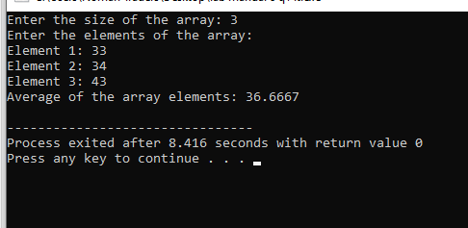

Q2.

using namespace std;

void swap(int &a, int &b) {

int temp = a;

a = b;

b = temp;

}

void bubbleSort(int arr[], int n) {

for (int i = 0; i < n - 1; ++i) {

for (int j = 0; j < n - i - 1; ++j) {

if (arr[j] > arr[j + 1]) {

swap(arr[j], arr[j + 1]);

}

}

}

}

int main() {

int arr[5];

cout << "Enter 5 integers for the array:" << endl;

for (int i = 0; i < 5; ++i) {

cout << "Element " << i + 1 << ": ";

cin >> arr[i];

}

bubbleSort(arr, 5);

cout << "Sorted array using Bubble Sort: ";

for (int i = 0; i < 5; ++i) {

cout << arr[i] << " ";

}

return 0;

}

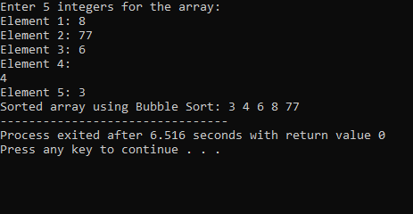

Q3.

#include<iostream>

using namespace std;

void swap(int &a, int &b) {

int temp = a;

a = b;

b = temp;

}

void selectionSort(int arr[], int n) {

for (int i = 0; i < n - 1; ++i) {

int minIndex = i;

for (int j = i + 1; j < n; ++j) {

if (arr[j] < arr[minIndex]) {

minIndex = j;

}

}

swap(arr[i], arr[minIndex]);

}

}

int main() {

int arr[5];

cout << "Enter 5 integers for the array:" << endl;

for (int i = 0; i < 5; ++i) {

cout << "Element " << i + 1 << ": ";

cin >> arr[i];

}

selectionSort(arr, 5);

cout << "Sorted array using Selection Sort: ";

for (int i = 0; i < 5; ++i) {

cout << arr[i] << " ";

}

return 0;

}

